**Comparison of multiple tests for determination of seroconversion rates to the Chlamydia trachomatis antigen Pgp3: a multi-country analysis.**

Authors: Please add name as you want it to appear and affiliation

Diana Martin, Division of Parasitic Diseases and Malaria, Centers for Disease Control and Prevention, Atlanta GA USA

Sarah Gwyn, Division of Parasitic Diseases and Malaria, Centers for Disease Control and Prevention, Atlanta GA USA

Data manager (Ana Bakhtiari or Sarah Boyd) Task Force for Global Health, Decatur GA, USA

Emma M. Harding-Esch, Clinical Research Unit, London School of Hygiene & Tropical Medicine, London, UK

Anthony W. Solomon, Department of Control of Neglected Tropical Diseases, World Health Organization, Geneva, Switzerland

Jessica Randall, Emory Integrated Computational Core, Woodruff Health Sciences Center, Emory University, Atlanta, GA, USA

**The authors alone are responsible for the views expressed in this article and they do not necessarily represent the views, decisions or policies of the institutions with which they are affiliated.**

**Introduction**

Trachoma, an eye disease caused by repeated ocular infection with the bacterium *Chlamydia trachomatis (Ct)*, is the leading infectious cause of blindness and is targeted for elimination as a public health problem. The elimination target of less than 5% trachomatous inflammation—follicular (TF) in children aged 1–9 years leaves open the possibility of low-level transmission after the cessation of interventions. These interventions—mass drug administration (MDA) of antibiotics and campaigns to encourage facial cleanliness and environmental improvement—comprise the A, F, and E components of the SAFE strategy (“S” is for surgery to correct morbidity associated with trichiasis). Tools are needed to monitor for recrudescence in settings where elimination of trachoma as a public health problem has been validated.

A growing body of evidence demonstrating the utility of serology for post-validation surveillance is being generated (Martin PLOS NTDs in press, [1-7]. While serology has no diagnostic utility for trachoma at an individual level, the longevity of the anti-*Ct* antibody responses are appropriate for assessing trends in transmission at population level over time. This may be particularly apposite for trachoma, for which host immune responses to repeated ocular *Ct* infections are critical for development of pathology. One important question is an appropriate threshold of seropositivity for trachoma programs. Preliminary models from multi-country serological data analyses suggest that a mean seroprevalence less than 6.2% and a seroconversion rate (SCR) of below 1.5 per 100 individuals per year in 1–9-year-olds correspond to a TF of less than 5%. [5]. However, more data are needed to evaluate the relationship between overall seroprevalence, SCR and TF in settings in various stages in the elimination process.

Another important consideration for serosurveillance studies is the choice of test to measure anti-*Ct* antibodies. Because of the discordance between the longevity of infection and antibody positivity, there is no gold standard for antibody tests — i.e. a test that can tell who has been exposed sufficiently to generate an antibody response. Antibodies against Pgp3 were first identified by ELISA [8], and subsequently have undergone various revision [9-11]. We previously adapted testing for anti-Pgp3 antibodies to a multiplex bead assay (MBA), in order to allow evaluation of antibody tests in trachoma-endemic settings within a multiplexed, integrated, serological surveillance platform [2]. This was later modified to an ELISA with a series of plate control standards to normalize absorbance values to standardize testing between laboratories [9]. The test was also adapted to a lateral flow assay (LFA) to provide a rapid, low-cost, low-technical capacity alternative to ELISAs or MBA [12, 13].

As tests are being developed and evaluated in a variety of epidemiological settings, it is important to use the data and user feedback to further optimize the tests under development, and ultimately to work towards rationalizing the menu of options available as consensus emerges on the target product profile. Here, we compare seroconversion rate (SCR) and seroprevalence estimates from four evaluation units in two countries (Togo and Democratic Republic of the Congo [DRC]) using multiple versions of the LFA and the MBA, including an improved version of the LFA using black latex as a developing reagent.

**Methods**

*Ethics*

Ethical approval for individual studies was given by institutional review boards at the Togo Ministry of Health and Social Protection and the Democratic Republic of the Congo National Program for the Fight Against Tropical and Preventative Chemotherapy Diseases. Written parental consent was obtained for study participants, all of whom were aged <18 years. CDC staff did not interact with study participants or have access to identifying information and were considered to be non-engaged in research.

*Study Sites*

In Togo, baseline mapping was conducted in 7 provinces in August–September 2017 to determine possible needs for intervention, and in 2 provinces, blood was drawn to create dried blood spots (DBS) and conduct field testing of the Pgp3 lateral flow assay. In DRC, dried blood spots were collected as part of baseline mapping in 2 districts of Tanganikya province in July 2018. Studies were conducted in accordance with WHO recommendations for trachoma prevalence surveys [14].

*TF grading:*

Graders from all studies underwent training from certified Tropical Data trainers, using international protocols [15] including published quality assurance mechanisms. TF was recorded as the presence of 5 or more follicles, each at least 0.5 mm in diameter, in the central part of the upper tarsal conjunctiva of one or both eyes.

*DBS collection:*

Fingerprick blood was collected onto filter paper containing 6 circular extensions calibrated to absorb 10 µL of blood (TropBio Pty Ltd., Townsville, Queensland, Australia). Filter paper wheels were dried overnight and put into cold storage (storage conditions within X days - each group fill in) and DBS were stored long term at -20°C with desiccant. DBS were shipped at ambient temperatures to CDC for analysis.

*MBA*

Each DBS extension was eluted overnight at 4°C in PBS containing 0.5% casein, 0.3% Tween 20, 0.5% polyvinyl alcohol, 0.8% polyvinylpyrrolidone, 0.02% sodium azide, and 3 µg/mL *E. coli* extract (Buffer B). DBS eluates were diluted in Buffer B to a final dilution of 1:400. Dilutions were tested on the multiplex bead assay as previously described [2] . Pgp3 and CT694 coupled beads (1250 per antigen per well) were incubated for 1.5 hours with 50 µL of diluted sample. Wells were washed 3 times with PBST (0.3% Tween 20) and incubated with 50 ng biotinylated mouse anti-human IgG (Southern BioTech, Birmingham, AL) and 20 ng biotinylated mouse anti-human IgG4 (Southern BioTech) for 45 minutes to detect any Pgp3 and CT694 specific IgG bound to the beads. After 3 washes with PBST, wells were incubated with 250 ng phycoerythrin-labeled streptavidin (Invitrogen, South San Francisco, CA) for 30 minutes. Wells were washed 3 times with PBST and incubated with 50 µL PBS containing 0.5% BSA, 0.05% Tween-20 and 0.02% sodium azide to remove any loosely bound antibodies. After one more wash with PBST, wells were suspended in 100 µL PBS and plates were stored overnight at 4°C. The next day, plates were read on a Bio-Plex 200 instrument (Bio-Rad, Hercules, CA) equipped with Bio-Plex manager 6.0 software (Bio-Rad). The median fluorescence intensity (MFI) with the background from the blank well (Buffer B alone) subtracted out (MFI-bg) was recorded for each antigen for each sample. The cutoff of positivity was established as an MFI-bg of 1647 for Pgp3 and 347 for CT694 by using receiver operator characteristic curve analysis on a panel of 101 PCR positives samples from the United Republic of Tanzania and 74 negative pediatric samples from New York, NY USA.

*LFA*

Manufacturing:

Pgp3 LFAs in cassettes for field testing in Togo were manufactured at CDC as previously described [12]. The production of Pgp3 LFA-dipsticks at CDC for the LFA-gold assay has also been previously described [13]. Pgp3 LFA-dipsticks for the LFA-latex assay were manufactured at CDC as follows: A nitrocellulose membrane (Sartorius, Bohemia, NY) and an absorbent pad were placed on a backing card with a 1–2 mm overlap. Pgp3 protein (0.5 mg/mL) and biotinylated bovine serum albumin (BSA-biotin, 1.0 mg/mL; Arista Biologicals, Allentown, PA) were dispensed onto the nitrocellulose membrane at a rate of 0.1 µL/mm using a BioDot XYZ 3060 dispenser (BioDot, Irvine, CA) and then dried overnight in a desiccator cabinet with a relative humidity of less than 20. Dried membranes were cut into 4 mm strips using an A-point guillotine cutter (Arista Biologicals) and stored at room temperature in a desiccator cabinet with a relative humidity of less than 20.

LFA-Field

Blood was run on the Pgp3 LFA cassette in Togo as previously described [12]. Fingerstick blood (20 µL) was transferred into the sample port of the Pgp3 LFA cassette using a micropipette (Safe-Tec, Ivyland, PA). Chase buffer (0.3% Tween 20 in PBS) was added to the buffer port and tests were read as positive, negative or invalid 30 minutes later.

LFA-Gold-

DBS were tested by the LFA-dipstick assay using a gold detector reagent [13]. Each DBS extension was eluted in 60 µL of LFA buffer (0.5% BSA, 0.3%-1% Tween-20, 0.02% sodium azide in PBS) for 4–24 hours in a flat-bottom 96-well plate (USA Scientific, Ocala, FL). SA-gold conjugate (Arista Biologicals) and Pgp3-gold conjugate (Expedeon, San Diego, CA) was added to each well no more than 4 hours prior to testing. Pgp3 LFA-dipsticks were placed into each well for 15-20 minutes. Then, 40 µL of LFA buffer was added. After 5–10 minutes, LFAs were removed and read as positive, negative or invalid.

LFA-Latex

DBS were tested by the LFA-dipstick assay using a black latex detector reagent. Pgp3-latex (Expedeon) and SA-gold (Arista Biologicals) were diluted 1:240 and 1:120, respectively, in PBST (0.3% Tween-20 in PBS) to create a conjugate mastermix. Each DBS was eluted in 60 µL of conjugate mastermix in a well of a flat-bottom 96-well plate overnight at 4°C. Pgp3 LFA-dipsticks were added to each well and incubated for 15 minutes, until all the liquid was absorbed. PBST (80 µL) was then added to each well to clear the background caused by hemolyzed red blood cells on the nitrocellulose membrane. Each LFA was read as positive, negative or invalid once the background was completely cleared (about 5 minutes).

*Statistical analysis*

Seroconversion rates were calculated using R (version 3.6.3), as previously described [5].

**Results**

*Demographic information and TF data*

Togo:

In Keran province, a total of 1540 1–9-year-olds were enrolled in the study. Of these individuals, 787 (51.1%) were male and 1523 (98.9%) had DBS collected. In Anie province, a total of 1502 1–9-year-olds were enrolled in the study. Of these individuals, 731 (48.7%) were male and 1429 (95.1%) had DBS collected. The number of samples tested by each assay in each province is shown in Figure 1. The age-standardized prevalence of 1–9-year-olds with TF was 0.38% in Keran and 0.27% in Anie (Table 1). Intensity of antibody responses by year of age are shown in Figure 2, and seroprevalence by year of age is shown in Figure 3.

DRC:

In Manono, a total of 1600 1—9-year-olds were enrolled in the study. Of these individuals, 784 (49.0%) were male and 1591 (99.4%) had DBS collected. In Nyemba, a total of 1677 1–9-year-olds were enrolled in the study. Of these individuals, 895 (53.4%) were male and 1662 (99.1%) had DBS collected. The number of samples tested by each assay in each province is shown in Figure 1. The prevalence of 1–9-year-olds with TF was 7.3% [95% CI 4.2–11.6] in Manono and 1.1% [95% CI 0.5–1.8%] in Nyemba (Table X). Intensity of antibody responses by year of age are shown in Figure 2, and seroprevalence by year of age is shown in Figure 3.

*Seroprevalence estimates*

Table 1 shows the age-adjusted seroprevalence of 1–9-year-olds by test format for each EU included. The EU with TF > 5% (Manono) had a seroprevalence of >25% on each of the assays (Table 1). The EUs with TF <5% had a seroprevalence <5% on all assays except the LFA cassette in Keran (7.7%, 95% CI: 4.1-14.2) and CT694 MBA in Nyemba (6.1%, 95% CI: 5.0-7.6). Confidence intervals were overlapping between Pgp3 MBA and each type of test for each EU except the Pgp3 LFA cassette (Keran).

|  |  |  |  |  |  |  |  |
| --- | --- | --- | --- | --- | --- | --- | --- |
| **Country** | **EU** | **TF**  **% (95% CI)** | **Pgp3 MBA**  **% (95% CI)** | **CT694 MBA**  **% (95% CI)** | **Pgp3 LFA cassette**  **% (95% CI)** | **Pgp3 LFA gold**  **% (95% CI)** | **Pgp3 LFA black latex**  **% (95% CI)** |
| Togo | Keran | 0.38 | 2.8 (1.3-6.4) | 2.8 (1.3-6.5) | 7.7 (4.1-14.2) | 4.4 (2.3–8.7) | 2.4  (1.0–5.9) |
| Anie | 0.27 | 4.4 (2.3-8.7) | 4.8 (2.5-9.3) | 2.4 (0.8-7.5) | 3.7 (1.8–8.1) | 4.5  (2.3–9.3) |
| DRC | Manono | 7.3  (4.2–11.6) | 28.3 (22.2–35.5) | 26.9  (20.9–34.0) | ND | ND | 29.8 (23.7–37.2) |
| Nyemba | 1.1  (0.5–1.8) | 4.1 (2.1–8.2) | 6.1  (3.4–10.6) | ND | ND | 4.9 (2.6–9.1) |

Table 1. Age-adjusted prevalence of trachomatous inflammation-follicular (TF) and anti-Ct antibodies by different immunoassays. EU = evaluation unit; CI = confidence interval; Pgp3 = plasmid gene product 3; CT = *Chlamydia trachomatis;* MBA = multiplex bead assay; LFA = lateral flow assay; ND = not done.

*Seroconversion rate estimates*

Table 2 shows the seroconversion rate per 100 children per year for each test format in each EU. The EU with TF > 5% (Manono) had seroconversion rates above 10 on the all tests. The EUs with TF < 5% had seroconversion rates below 1.5 for Pgp3 MBA and Pgp3 LFA latex but not CT694 MBA (Nyemba and Anie), Pgp3 LFA cassette (Keran) or Pgp3 LFA gold (Keran) (Table 2).

|  |  |  |  |  |  |  |
| --- | --- | --- | --- | --- | --- | --- |
| **Country** | **EU** | **Pgp3 MBA**  **% (95% CI)** | **CT694 MBA**  **% (95% CI)** | **Pgp3 LFA cassette**  **% (95% CI)** | **Pgp3 LFA gold**  **% (95% CI)** | **Pgp3 LFA latex**  **% (95% CI)** |
| Togo | Keran | 1.1 (0.5–2.1) | 1.0 (0.7–1.6) | 4.2 (2.4–9.1) | 4.3 (2.0–8.1) | 0.6 (0.4–1.1) |
| Anie | 1.0 (0.7–1.7) | 1.6 (1.1–2.4) | 1.2 (0.7–2.3) | 1.0 (0.7–1.6) | 1.1 (0.8–1.8) |
| DRC | Manono | 10.4  (8.0–13.3) | 10.2 (8.1–12.6) | ND | ND | 10.6 (8.2–14.1) |
| Nyemba | 1.2 (0.8–2.0) | 4.2 (2.8–6.0) | ND | ND | 1.5  (1.0–2.7) |

Table 2. Seroconversion rates (SCR) by different immunoassays. EU = evaluation unit; CI = confidence interval; Pgp3 = plasmid gene product 3; CT = *Chlamydia trachomatis;* MBA = multiplex bead assay; LFA = lateral flow assay; ND = not done.

**Discussion**

Serology is likely to be an important component of post-validation surveillance for countries that have been validated as having eliminated trachoma as a public health problem. It has the advantage of using a sample type (blood or blood products) that is often taken for other disease surveillance and therefore could use stored specimens, saving resources. But for serology to be widely adapted for trachoma surveillance, we first must validate that serological tests are fit for purpose by evaluating in population surveys in endemic and non-endemic areas. Here we show distinct differences in seroprevalence and SCR in a district with a relatively low TF prevalence (Manono, DRC, at 7.5% TF) compared to three other districts with TF < 5%. These data contribute to the growing body of evidence that serological data – both seroprevalence and seroconversion rates – generated by either rapid or bead-based tests reflect population-level TF prevalence.

Seroprevalence seen in the three non-endemic districts is similar to what has been observed in pre-validation surveys in Ghana [16], Nepal [7], and Tanzania [6]. The data from Manono, where TF was 7.5%, is similar to what was seen in 1–5-year-olds in Niger when TF was 7.5% after 3 rounds of MDA [17]. For a few of the individual tests in the 3 non-endemic districts, notably the Pgp3 LFA cassette in Keran and the CT694 MBA in Nyemba, the seroprevalence and SCR are both higher that the predicted levels for nonendemic countries (6.2% for seroprevalence and 1.5 for SCR, Pinsent). These early modeling predictions will be improved by the inclusion of serological data from countries from Sub-Sarahan Africa, which carries the largest trachoma burden. Existing models are over-represented by data from Pacific Island nations, which early on used serological testing as an alternative indicator of trachoma to understand the discordance between high TF in children and low TT and blindness in adults [18-20]. As such, addition of serology testing to baseline surveys has been prioritized to determine seroprevalence and SCR in trachoma-endemic populations (Martin *PLOS NTDs in press*). The rapid implementation of trachoma mapping through the Global Trachoma Mapping Program [14] leaves few areas to be mapped, so these data are especially valuable for creating better thresholds for trachoma serological.

There were several limitations to this study. In Togo, the study design pre-specified that we would test only the first 1000 people per EU on the LFA-field test in anticipation of testing all residents (approximately N = 4500 per EU), but it was later decided to test only 1-9-year-olds. We therefore have field tests from just shy of the total number collected and therefore cannot generate accurate district-wide prevalence data from the field LFA data in Togo. The lack of a gold standard reagent prevents us from establishing the accuracy of different tests for anti-Ct antibody tests, and so we currently rely on agreement between tests in population-based studies and triangulating that data with clinical and infection data to determine the best tests for use. The lack of infection data in these surveys also therefore limits our ability to interpret these data. There is a certain degree of subjectivity in reading the LFA, so despite strong population-level agreement amongst the different tests, it is difficult to disentangle whether between-test variation is due to test performance or differences in raters.

In baseline mapping of two provinces in Togo, population-level estimates for seroprevalence and SCR were essentially equivalent when using the Pgp3 MBA, CT694, MBA, and the Pgp3 black latex LFA. Estimates were 2–3 times higher using the Pgp3-gold dipstick LFA or the LFA-cassette. The LFA-cassette had previously shown poorer sensitivity to detect current infection [9] and incorporation of this test with whole blood resulted in poor model fits in latent class analysis [21]. As such, use of this test in the field has been discontinued, as it is unlikely to be necessary to have point-of-care testing for trachoma surveillance [9]. The Pgp3-gold dipstick LFA differed only slightly from the MBA and had overlapping Cis with the black latex LFA. The black latex LFA was developed in response to population-level serosurveys in which a number of presumed false positives were detected and poor inter-rater agreement was seen (Gwyn and Laurent, manuscript in preparation). Additional comparison with the Pgp3 MBA in 2 districts of DRC again show strong agreement between MBA-derived seroprevalence and SCR and Pgp3 black latex-derived data. These data coupled with other unpublished data provides support of using black latex as a developing reagent for the Pgp3 LFA. Having tests available on multiple platforms will allow country programs flexibility in selecting the best assays for their needs, and we present here improved tests for use in population-level serosurveys for trachoma programs.

**REFERENCES**

1. Cama, A., et al., *Prevalence of signs of trachoma, ocular Chlamydia trachomatis infection and antibodies to Pgp3 in residents of Kiritimati Island, Kiribati.* PLoS Negl Trop Dis, 2017. **11**(9): p. e0005863.

2. Goodhew, E.B., et al., *CT694 and pgp3 as serological tools for monitoring trachoma programs.* PLoS Negl Trop Dis, 2012. **6**(11): p. e1873.

3. Martin, D.L., et al., *Serology for trachoma surveillance after cessation of mass drug administration.* PLoS Negl Trop Dis, 2015. **9**(2): p. e0003555.

4. Martin, D.L., et al., *Serological Measures of Trachoma Transmission Intensity.* Sci Rep, 2015. **5**: p. 18532.

5. Pinsent, A., et al., *The utility of serology for elimination surveillance of trachoma.* Nat Commun, 2018. **9**(1): p. 5444.

6. West, S.K., et al., *Can We Use Antibodies to Chlamydia trachomatis as a Surveillance Tool for National Trachoma Control Programs? Results from a District Survey.* PLoS Negl Trop Dis, 2016. **10**(1): p. e0004352.

7. West, S.K., et al., *Surveillance Surveys for Reemergent Trachoma in Formerly Endemic Districts in Nepal From 2 to 10 Years After Mass Drug Administration Cessation.* JAMA Ophthalmol, 2017. **135**(11): p. 1141-1146.

8. Comanducci, M., et al., *Humoral immune response to plasmid protein pgp3 in patients with Chlamydia trachomatis infection.* Infect Immun, 1994. **62**(12): p. 5491-7.

9. Gwyn, S., et al., *Comparison of Platforms for Testing Antibody Responses against the Chlamydia trachomatis Antigen Pgp3.* Am J Trop Med Hyg, 2017. **97**(6): p. 1662-1668.

10. Horner, P.J., et al., *Effect of time since exposure to Chlamydia trachomatis on chlamydia antibody detection in women: a cross-sectional study.* Sex Transm Infect, 2013. **89**(5): p. 398-403.

11. Wills, G.S., et al., *Pgp3 antibody enzyme-linked immunosorbent assay, a sensitive and specific assay for seroepidemiological analysis of Chlamydia trachomatis infection.* Clin Vaccine Immunol, 2009. **16**(6): p. 835-43.

12. Gwyn, S., et al., *Lateral flow-based antibody testing for Chlamydia trachomatis.* J Immunol Methods, 2016. **435**: p. 27-31.

13. Gwyn, S., et al., *Optimization of a rapid test for antibodies to the Chlamydia trachomatis antigen Pgp3.* Diagn Microbiol Infect Dis, 2019. **93**(4): p. 293-298.

14. Solomon, A.W., et al., *The Global Trachoma Mapping Project: Methodology of a 34-Country Population-Based Study.* Ophthalmic Epidemiol, 2015. **22**(3): p. 214-25.

15. Thylefors, B., et al., *A simple system for the assessment of trachoma and its complications.* Bull World Health Organ, 1987. **65**(4): p. 477-83.

16. Senyonjo, L.G., et al., *Serological and PCR-based markers of ocular Chlamydia trachomatis transmission in northern Ghana after elimination of trachoma as a public health problem.* PLoS Negl Trop Dis, 2018. **12**(12): p. e0007027.

17. Oldenburg, C.E., *One Size Does Not Fit All: Achieving Trachoma Control by 2030.* Am J Trop Med Hyg, 2019. **101**(6): p. 1189-1190.

18. Butcher, R., et al., *Ocular Chlamydia trachomatis infection, anti-Pgp3 antibodies and conjunctival scarring in Vanuatu and Tarawa, Kiribati before antibiotic treatment for trachoma.* J Infect, 2020. **80**(4): p. 454-461.

19. Butcher, R., et al., *Clinical signs of trachoma are prevalent among Solomon Islanders who have no persistent markers of prior infection with Chlamydia trachomatis.* Wellcome Open Res, 2018. **3**: p. 14.

20. Cocks, N., et al., *Community seroprevalence survey for yaws and trachoma in the Western Division of Fiji.* Trans R Soc Trop Med Hyg, 2016. **110**(10): p. 582-587.

21. Wiegand, R.E., et al., *Latent class modeling to compare testing platforms for detection of antibodies against the Chlamydia trachomatis antigen Pgp3.* Sci Rep, 2018. **8**(1): p. 4232.

Figure 1. Data collection and testing flow charts.

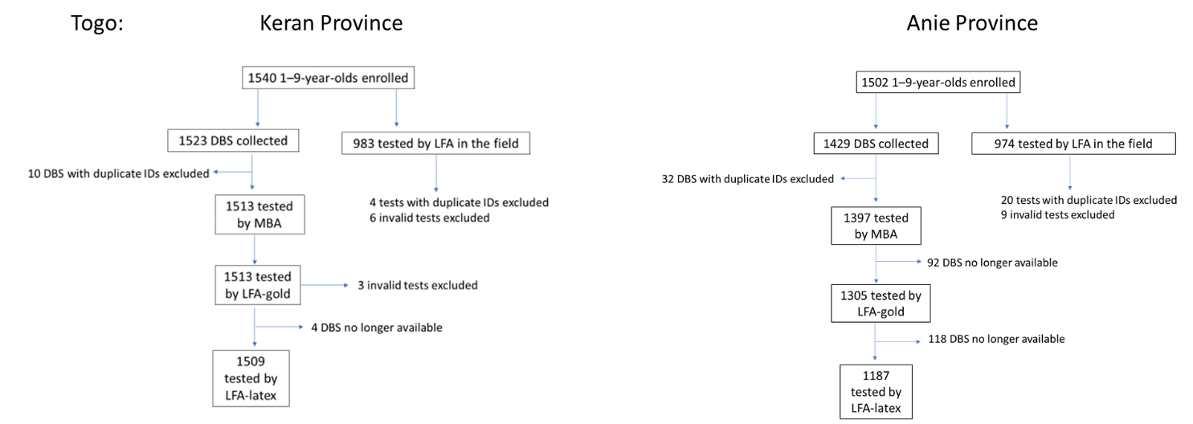

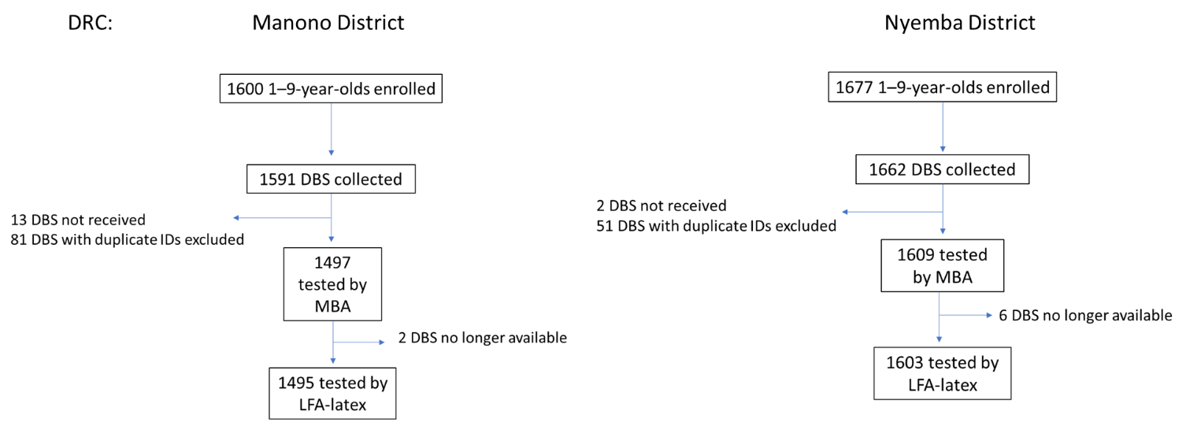

Figure 2 Intensity of antibody response by district. a Manono district, Democratic Republic of Congo (DRC); b Nyemba district, DRC; c Keran province, Togo; d Anie province, Togo. Y-axis shows median fluorescence intensity with background subtracted (MFI-bg), x-axis shows year of age.

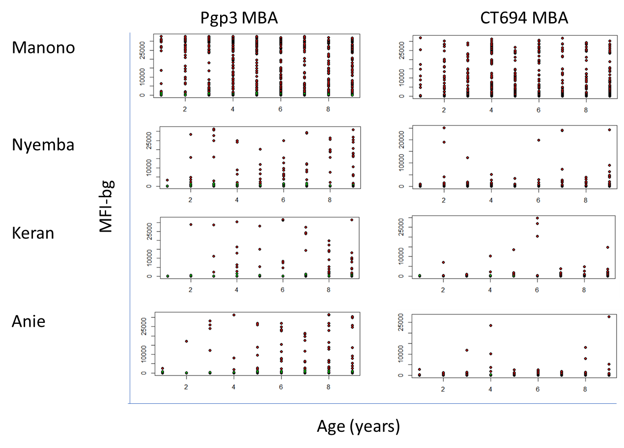

Figure 3 Seroprevalence by year of age.. MBA = multiplex bead assay; LFA = lateral flow assay, N.D. = not done.

